Empowering Math Learning with Real-Time AI Assistance with MAPP Android Application

Olivia Arroyo1, Xiaofeng Leng2, Amélie Obas3

*Seidenberg School Of Computer Science and Information Systems - Pace University*

1[oa92316n@pace.edu](mailto:1oa92316n@pace.edu), 2 [xl98363p@pace.edu](mailto:xl98363p@pace.edu), 3 [ao89721p@pace.edu](mailto:ao89721p@pace.edu)

***Abstract–* The Math APP (MAPP) is an AI-powered educational tool designed to support students in overcoming math challenges and provide educators a way to monitor and analyze students’ performance. By utilizing word recognition, the application classifies the math word problem from a camera and provides comprehensive solutions that includes scaffolded explanations, sample problems, and interactive tutorials. This real-time support empowers students to gain an understanding at their own pace while allowing teachers and tutors to track students’ progress and customize their teaching methods according to the students’ performance. MAPP's goal is to transform math education by providing accessibility, engagement, and efficiency to student learning.**

***Keywords– Machine Learning, TensorFlow Lite, Keras, Text Classification, Mathematics Application, Education, Learning, Pedagogy***

1. INTRODUCTION

The use of technology has increased greatly and reshaped the educational landscape, especially in mathematics. Technologies, such as softwares (Khan Academy, Desmos) and scientific calculators (TI 89 Plus CE), have become the norm in many classrooms. A big contrast from the traditional mathematics classroom, where students used pen/pencil and paper.

With the rise of applications, the option for quick solutions to homework problems have become accessible to students with the aid of image and word recognition. Even though these tools might be convenient for them, their chances to foster deep conceptual understanding, going through the stages of problem solving and critical thinking falls short. This dependence blocks learning and destroys the foundation of mathematical skills.

In order to close this gap, an effective approach is needed. The Math APP (MAPP) looks to reexamine the role that technology has taken in mathematics and tries to redefine it by providing a comprehensive solution. Compared to the current problem solving apps, MAPP is focused on coaching students through the problem solving process rather than providing quick answers. By combining image or word recognition with AI driven instructional support, MAPP empowers students and helps build their confidence so that they can become independent learners. At the same time, educators will be able to gain insights into their students’ performance.

1. LITERATURE REVIEW

In today’s educational landscape, technology plays an essential role in developing problem-solving skills in mathematics. This literature review examines diverse tools in technology and their effect on strengthening problem-solving skills in mathematics, focusing on interactive software, online platforms, and high-level thinking foundations.

1. *Interactive Digital Tools for Problem-Solving in Mathematics*

Online platforms have become essential tools in mathematics. There are a variety of digital tools, such as simulation real-world models like Desmos, game-based platforms like Kahoot!, and tutoring systems, providing interactive challenges and personalized learning and feedback. Research consistently highlights the potential of interactive software to enhance problem-solving skills by fostering engagement, deepening conceptual understanding, and developing critical thinking abilities [1]. Greefrath, Hertlief, & Siller states that the use of digital tools can enhance learning and teaching within technology-related subjects [2]. It supports skills and strategies for real-world problem solving [2]. However, many digital tools just give quick answers with insufficient explanations. This creates a lack of deep conceptual understanding. MAPP will allow students to obtain a comprehensive solution and the opportunity to understand mathematical concepts in depth. In addition, provide personalized, scaffold support in order to foster strong problem-solving skills.

1. *Engagement Through Digital Platforms*

The merging of mathematics education and digital tools have played a part in increasing students’ engagement while learning. These digital tools give students the chance to take ownership of their learning and transform it from passive to active learning experiences. Research states that [3] when students are actively involved in their learning process by use of simulations, interactive exercises, and real-world problem-solving, their motivation and interest are enhanced greatly. MAPP offers customized learning experiences so students' confidence and mastery levels can be boosted while having fun.

By giving quick feedback and adapting personalized learning paths, digital tools can enhance the students’ learning enviroment. This continuous interaction will create an enjoyable learning experience. MAPP will have the ability for students to track their progress, acknowledge their achievements, and point out areas for improvement.

1. *Technology’s Role in Cultivating Critical Thinking.*

High-level thinking involves a range of cognitive processes that includes creativity, problem-solving, and critical thinking. Critical thinking combines analyzing and evaluating information [4]. It has been shown that students who use technology have their problem-solving skills enhanced, are capable of analyzing data, identifying patterns, and able to think outside the box [4]. In order to foster critical thinking, MAPP will allow students to access practice problems that will encourage them to figure out the process to solve the problem with creativity and understanding.

*D. Conclusion*

Technology has become the driving force in transforming how mathematics deals with problem-solving skills. This literature review highlights the opportunity and impact that digital tools have on sparking student engagement, deepening understanding, and fostering critical thinking. Future research should explore the ability for these tools to scaffold contents and provide comprehensive feedback.

1. PRODUCT REQUIREMENTS

The objective of this product is to develop an Android based mobile application called “ The Math APP (MAPP)” that is designed to identify math problem topics through real-time text classification and provide references for step-by-step instructions, model problems and interactive tutorials. The application should be user-friendly and provide real-time text classification of math problems to students

*A. Functional Requirements*

The following are the functional requirements for the Math APP application:

1. User Selection: The application should allow users to select whether they are an instructor or a student.
2. Input Space: The application should allow users to type a math problem and submit the problem for classification.
3. Display Classification Results: The application should provide the users with a content area of the submitted math problem.
4. Display References: The application should provide users with a list of references relevant to the content area.
5. Platform: The application should be developed for Android devices.
6. Programming language: The application should be written in the Java, Python and XML programming language.
7. Frameworks and libraries: The application should use Tensorflow Lite for the machine learning tasks of text classification.
8. Minimum OS version: The application should support the Android 8.0 version or newer.
9. Machine learning model: The application should use a pre-trained machine learning model to analyze the inputted mathematical text problems and provide an appropriate text classification of the type of problem.

*B. Non-functional Requirements*

The following are the non-functional requirements for the Math APP application:

1. Usability: The application should have a user-friendly UI.
2. Performance: The application should be able to analyze inputted math problems and accurately display the correct content classification supplemented with learning resources.
3. Compatibility: The application should be compatible with Android devices.

*C. Constraints*

The following are the constraints for the Math APP application:

1. Technical Constraints: The application must use suitable technologies and frameworks to ensure consistent and accurate performance on Android devices.
2. Economic Constraints: Development and maintenance of the application should be cost-effective.
3. Time Constraints: The application is required to be developed and evaluated within the time constraints by the mandated deadline.
4. METHODOLOGY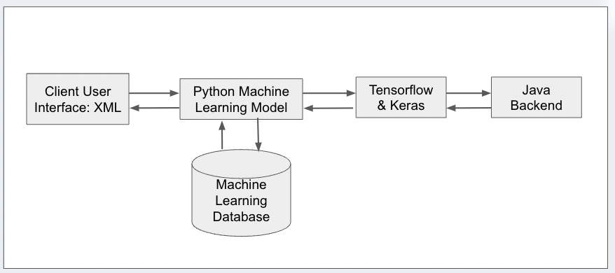

Fig. 1 Conceptual Architecture Diagram

*A. Architecture*

The architecture of the Math APP application includes numerous programming languages and two API’s to connect to the backend of the application. The Math APP application has a client user interface that is in XML. The Python machine learning model uses Keras to connect with Tensorflow Lite. The Tensorflow Lite and Keras API’s connect with the Java backend. The architecture of the Math APP is demonstrated in the Conceptual Architecture Diagram in Figure 1.

*B. User Frontend*

The MAPP application utilized Figma, Canva and Android Studio to ensure real-time interface design and creation. Android Studio served as the integrated development environment for editing the code. GitHub encouraged remote collaboration due to the remote repository hosting and version control features. The frontend of the application is created using an XML layout with buttons, text views and images views that creates an intuitive user interface.

*C. Backend*

The backend of the MAPP application utilizes the Java programming language to connect with the TensorFlow Lite API and the Python programming language to connect with the Keras API. The Class Diagram in Figure 2 demonstrates the different objects of the application. These include the First Login Page, the Student Main Activity, the Educator Main Activity and the Educator Subject Page. These ensure that when the user selects a different role of educator or student they are able to perform different operations within the application relevant to their role.

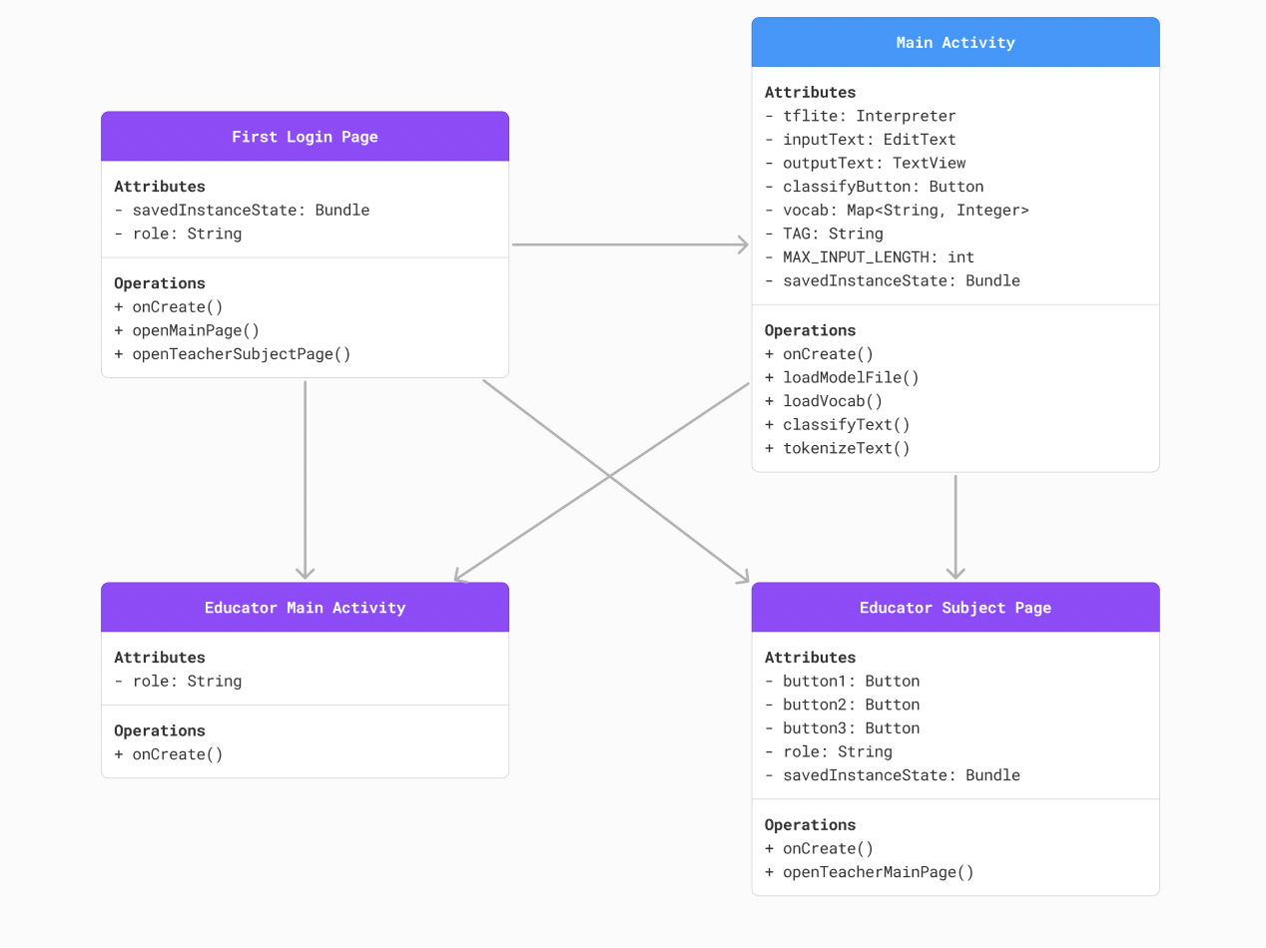

Fig. 2 Class Diagram

*D. Machine Learning Model*

TensorFlow is one of the most popular and widely used deep learning frameworks. Keras is another popular high level deep learning framework that works on the second level of abstraction and as a result simplifies the process of deep learning models such as TensorFlow Lite [6]. The combination of Keras and TensorFlow Lite is used within the Math APP application to deploy text classification using deep learning. Keras was utilized for building and training our machine learning models while TensorFlow Lite was used to deploy these models on a mobile Android device.

TensorFlow Lite is a framework that is closely integrated with Android mobile applications [5]. The MAPP application is being built on Android Studio, thus TensorFlow Lite was an appropriate machine learning tool to support our application. TensorFlow Lite deploys the trained models on mobile devices. Keras is a high- level neural networks API that supports other machine learning frameworks such as TensorFlow Lite. Keras allows developers to easily build and train deep learning models with an accessible syntax written in the Python programming language [6]. The process begins with building and training a model using Keras. This code written in Keras then gets converted to TensorFlow Lite to complete the machine learning model.

The machine learning model for the Math APP application resulted in an 89% accuracy as demonstrated in Figure 3. For the MAPP application, a dataset from Kaggle called Mathematical Problems Dataset: Various. The dataset was broken up into various mathematical contents and each set contained over 10,000 mathematical problems. Therefore, the accuracy of our model was good, providing the student user with an accurate classification of their homework problems they have submitted and providing them with appropriate and relevant learning resources.

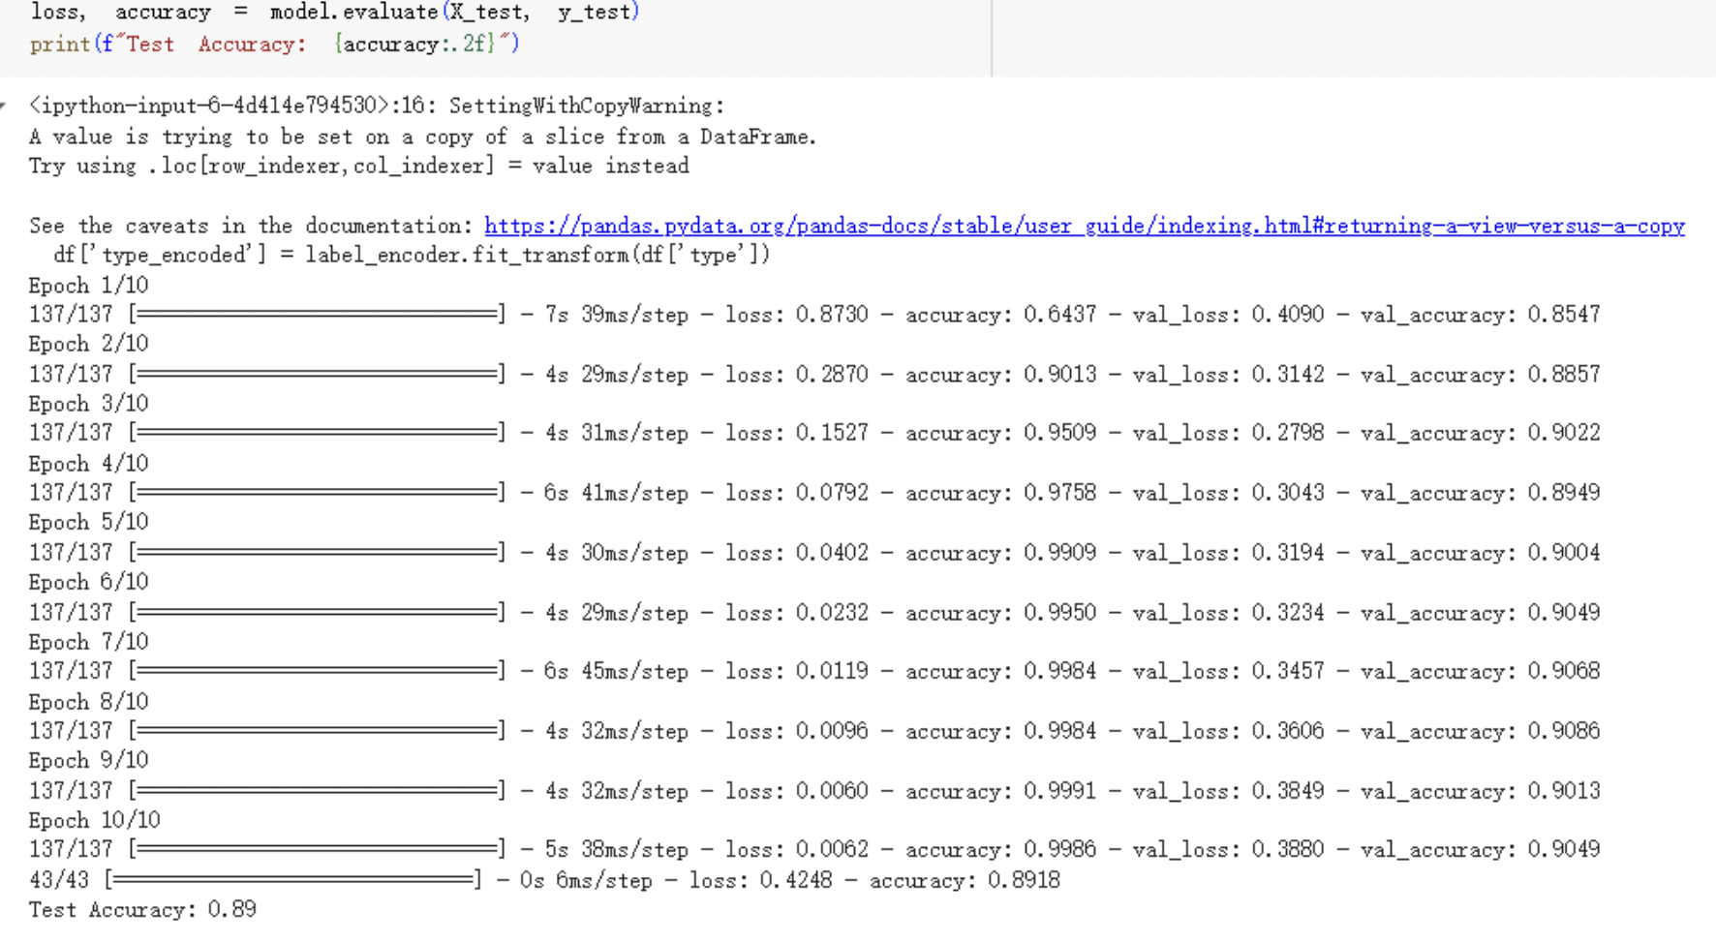

Fig. 3 Model Test Accuracy

1. CONCLUSIONS

The Math APP application is designed to help students tackle math problems effectively while providing educators with insights into student growth and struggles. It identifies math problem topics through real-time text classification and offers resources for step-by-step instructions, model problems and interactive tutorials. The application caters to students by providing resources relevant to their current learning needs and assists educators in gauging student understanding and mastery of the material.

Future enhancements to Math APP could further improve the student and educator experience. Some possible features could include creating a database to store the student progress so the educator (student and tutors) has real time access to the student’s progress, rather than having the student self report. Additionally, the resources could be directly embedded into the application rather than the user having to use links to direct them to these educational resources. With the implementation of these improvements, the application has the potential to be a valuable resource to support the learning journey for educators and students alike.

1. REFERENCES

[1] Song, H. and Cai, L. (2024) ‘Interactive learning environment as a source of critical thinking skills for college students’, BMC Medical Education, 24(1). doi:10.1186/s12909-024-05247-y.

[2] G. Greefrath, C. Hertleif, and H.-S. Siller, “Mathematical modeling with digital tools—a quantitative study on mathematising with dynamic geometry software,” ZDM, vol. 50, no. 1–2, pp. 233–244, Mar. 2018, doi: 10.1007/s11858-018-0924-6.

[3] A. Haleem, M. Javaid, M. A. Qadri, and R. Suman, “Understanding the role of digital technologies in education: A review,” *Sustainable Operations and Computers*, vol. 3, pp. 275–285, Jan. 2022, doi: 10.1016/j.susoc.2022.05.004.

[4] Johnson, J. (2003). Children, robotics, and education. Artificial Life and Robotics, 7(1-2), 16–21

[5] Karthikeyan, N. G. (2018). *Machine learning projects for mobile applications: build android and IOS applications using tensorflow lite and core ML.* Packt Publishing Ltd.

[6] Moolayil, J., Moolayil, J., & John, S. (2019). *Learn Keras for deep neural networks* (pp. 33-35). Berkeley, CA, USA: Apress.

[7] T. Wilkins, “Using technology to encourage critical thinking Using technology to encourage critical thinking.” Accessed: Oct. 23, 2023. [Online]. Available: https://scholarworks.uni.edu/cgi/viewcontent.cgi?article=2742&context=grp#:~:text=Databases%2C%20spreadsheets%2C%20concept%20mapping%20software